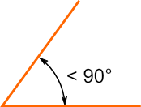
A
Absolute value—the distance a number is from zero
Acute angle—an angle that measures less than $90°$ (degrees)
Acute Angle

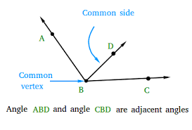
Additive inverse—the sum of any number and its opposite is zero. For example, the additive inverse of 1 is $-1$ because $1+-1=0$
Adjacent angles—angles that share a common side

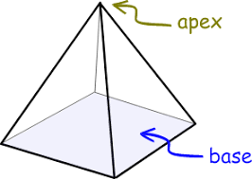
And probability—the probability of Event A and Event B occurring is the product of their individual probabilities. $P(A and B)= P(A)∙P(B)$
Apex—the highest point on a geometric figure

Area—the amount of space a two-dimensional drawing takes up
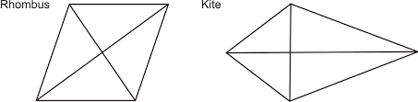

Area of a circle—is $π∙{radius}^{2}$
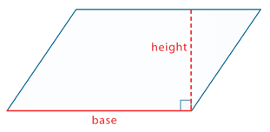
Area of a kite or rhombus—is $\frac{1}{2}∙diagonal one∙diagonal two$
Area of a parallelogram—is $base∙height$
Parallelogram
Area of a rectangle—is $base∙height$
Area of a semi-circle—take the area of the circle as usual (see area of a circle formula above) and then divide it by two (or divide it in half)
Area of a square—is $side∙side OR {side}^{2}$

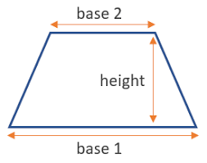
Area of a trapezoid—is $\frac{1}{2}∙height∙(base one + base two)$ (NOTE: you MUST find the sum of the two bases FIRST)
Area of a triangle—is $\frac{1}{2}∙base∙height$
Trapezoid

B
Base—the surface a solid object stands on or the ‘top’ or the ‘bottom’ of a geometric figure
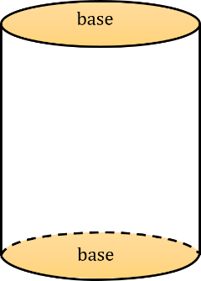
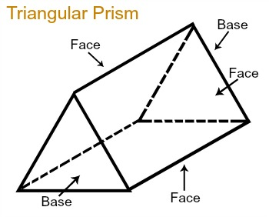
Cylinder
Square Pyramid

Box Plot (also known as a box and whisker plot graph)—a graph that shows (visually) how far apart and how evenly a data set is distributed
Maximum Value
Minimum Value
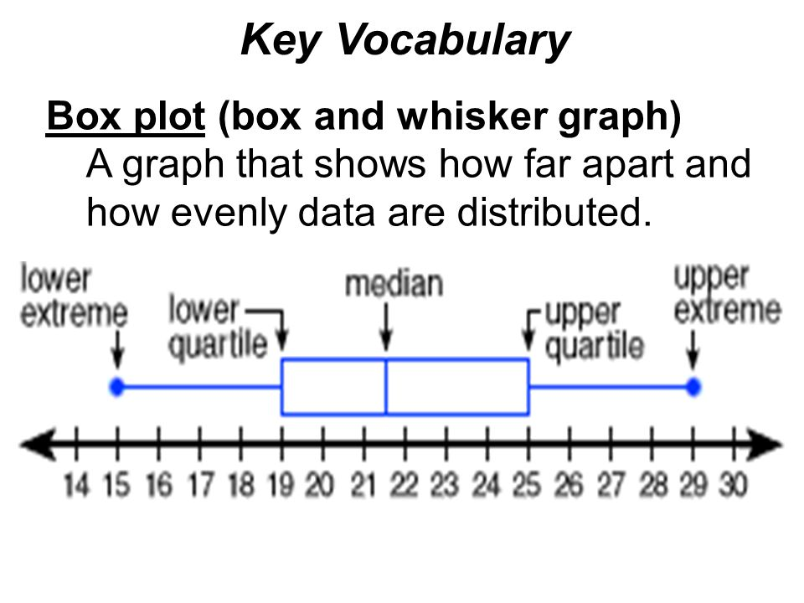

Interquartile Range

C
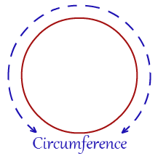
Certain event—an event with a 100% change of taking place
Circumference—the ‘perimeter’ (the space around) a circle

Circumference formula—is $π∙diameter OR 2∙π∙radius$

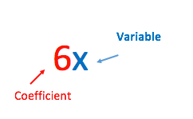
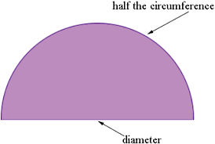
Circumference of a semi-circle—find the circumference of the circle as usual, divide it by two (divide it in half), then add the diameter back into the halved circumference (you do this because circumference is the same a ‘perimeter’ so you must include the flat side of the semi-circle now that it has been sliced in half)

Coefficient—the number in front of a variable

Commission—the amount of money a salesman earns for selling a product
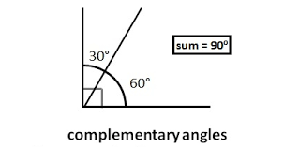
Complement—the probability that an event will not occur

Complementary angles—angles whose sum is $90°$ (degrees)

Complex fraction—when you are dividing one fraction by another with the following format $\frac{\frac{1}{2}}{\frac{1}{3}}$ (where you have a
fraction in either the numerator, the denominator, or both)

Composite figure—a figure that can be divided into two or more basic shapes (composite figures can also be referred to as irregular figures)
Cone
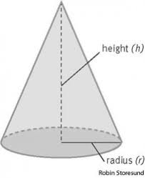
Compound events—events with a combination of outcomes (more than one outcome)

Cone—a geometric figure that has a circular base and meets at a point

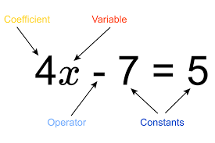
Congruent figures—geometric figures that are the exact same shape, the exact same size, and have the exact same angle measurements.
Variable
Coefficient
Constant—a number without a variable
Constants
Operator

Constant of proportionality (Unit Rate) formula—is $\frac{dependent (y)}{independent (x)}$
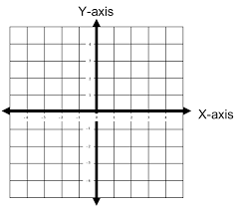
Coordinate plane— two-dimensional place with an x and y axis

Corresponding sides—sides that have the same relative position in two geometric figures

Counting your negative signs—when multiplying or dividing numbers ONLY you can count the number of negative signs within the problem. If you have an odd number of negative signs your final answer will be negative, but if you have an even number of negative signs your final answer will be positive.

Cross cancelation—Instead of reducing the fraction at the end of the problem, you cross cancel before you multiply

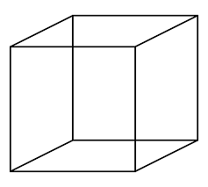

Cube
Cube—a symmetrical three-dimensional shape made by six equal squares
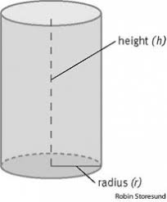
Cylinder—a geometric figure with two parallel, circular bases
Cylinder
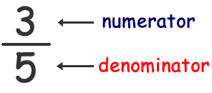
D
Denominator—the bottom number of a fraction
Dependent event—an event that relies on something else to take place (represented with the variable y) it depends on an independent event (see definition of independent event)
Dependent probability—a probability where the outcome or occurrence of the first event affects the outcome or occurrence of the second (if the first event does not happen, then the second event will not happen)
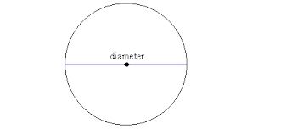
Diameter—the distance from one side of the circle to the other, crossing through the center of the circle (diameter will ALWAYS touch two opposite sides of the circle at the same time)

Discounts or markdowns—the amount by which a regularly priced item is reduced by a given percentage
Discounts rule—you must do the discount percentage first and then find the taxes from the new, discounted amount
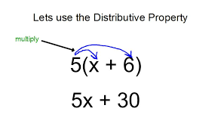
Distribute property—allows you to multiply separate quantities and then add the products together to simplify an expression (if simplification is possible)

Double negative signs rule—two negative signs side by side will cancel out to make a positive

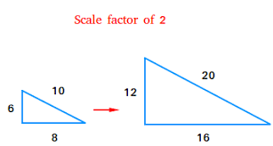
E
Enlargement (in scale drawings)—takes place if the post-image is LARGER/BIGGER than the pre-image, or the scale factor is GREATER than 1, 100%, or 1.0
Post-image
Pre-image

Equation—a statement that the two values of two mathematical expressions are equal (it will have an equal sign)
Equation word problem formula—is $px+q=r OR px-q=r$
Where: p is the value with your unknown, x is what you are looking for, q is your constant, and r is your total/solution
For example: Mark is buying snacks at the movies. He has $25 to spend. He bought a $12.50 combo and wants to spend the rest on candy that is $1.25 each. How much candy can he buy?
P=price of the candy bars; $1.25 each
X= number OF candy bars, which is unknown
Q= the price of the combo, your constant; $12.50
R= total amount of money; $25

$$1.25x+12.50=25$$
Your left-hand side will be equal to 25 because that is how much you have to spend.
He can get a total of 10 candy bars.

Equivalent—equal in value or amount; exactly the same
Equivalent expression—means that it is the same as the original expression but writing in a different way
$$2\left(3x+2\right)$$
Is an equivalent expression to
$$6x+4$$

Event—a desired (or successful) outcome or group of outcomes from an experiment
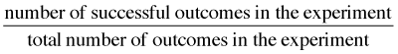
Experimental probability—probability based on data collected from experiments performed
Experimental probability=

Exponent—the power a number is raised to that tells you how many times to multiply that number by itself
Exponent rules—an exponent is multiplied by whatever is DIRECTLY next to it, therefore the following is true:
$4^{3}=4∙4∙4$
${-4}^{3}=4∙4∙4=-64$ (bring the negative at the end because the exponent is only with the constant: 4)
${(-4)}^{3}=-4∙-4∙-4=-64$ (multiply out by $-4$ because it is in parenthesis, meaning the exponent is with the entire thing, not just the four as show in the above example)

Expression—a mathematical phrase combining numbers and/or variables through the four operations of addition, subtraction, multiplication, and division that does NOT contain an equal sign

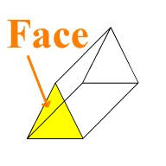
F
Face—the flat surfaces of a three-dimensional object

Factor—a number you can multiply to other to get a desired number
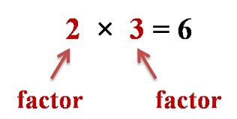

Fraction—a ratio of two numbers, which can be written in several different ways. A fraction will have a numerator and a denominator (see definitions of both), and shows you how much of a part of a whole you have.

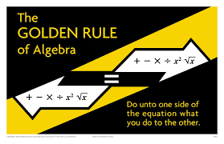
G
GCF—greatest common factor
Golden rule of algebra—what you do to one side of the equation/the equal sign, you must ALWAYS do the same to the other side

Gratuity—money given in return for some service, job, or favor done

H

I
Impossible event—an event with a 0% chance of taking place
Improper fraction—a fraction where the number in the numerator is larger than the number in the denominator for
example: $\frac{22}{5}$
example: $\frac{22}{5}$

Independent event—In control, something that happens without having to be told to or having someone act upon it, it stands on its own (represented with the variable x)

Independent probability—when the probability of one even occurring does not affect the probability of another event occurring (if there are multiple events, both will take place regardless if the other does or does not happen)

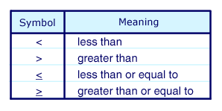
Inequality—a statement that two expressions are NOT equal, a comparison. For example: $x>5$ this statement means that x is all the numbers GREATER than five.
Inequality symbols—

Inequality word problems formula—is $px+q>r OR px+q<r OR px+q≥r OR px+q≤r$
Where: p is the value with your unknown, x is what you are looking for, q is your constant, and r is your total/solution
For example: Jane is at the store. She buys a bottle of soda for $5, then she buys candy bars for $2 each. She can spend at most $12. How many candy bars can she purchase?
P=price of the candy bars; $2
X= number OF candy bars, which is unknown
Q= the price of the soda, your constant; $5
R= total amount of money; $12

$$2x+5≤12$$
It would be less than or equal to her total because it says AT MOST $12. So she has $12 or less to spend.
Answer: $x≤3.5 or 3$candy bars
So, she can buy 1, 2, or 3 but NO more.

Integers—all the natural numbers and their opposites (negatives) and zero {…., -4, -3, -2, -1, 0, 1, 2, 3…..}
Interest formula—Interest = principal ($) x Rate (%) x time OR I=PRT
In terms of pi—when you are finding the area or circumference of a circle and you do NOT multiply by pi and leave the pi symbol ($π$) in the final answer
For example: A circle with a diameter of 12 in, what is the circumference?
Regular method: $12∙3.14=37.68 in$ In Terms of Pi ($π$): $12π in$ is the final answer

Interquartile Range—the middle 50% of your data set that goes from your upper quartile to your lower quartile

Irrational numbers—any number that cannot be expressed as a ratio (repeating decimals without a patters:
0.123456789556…. would be irrational where as 0.12121212…would be rational)
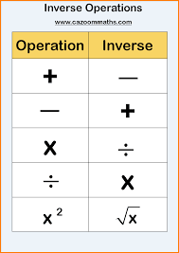
Inverse operation—operations that ‘undo’ each other
Ex: the inverse operation of multiplication is division
Ex: the inverse operation of addition is subtraction

J

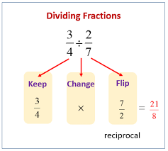
K
KCF OR KFC—keep, change, flip- when dividing fractions you keep the first fraction as it is, change the division symbol to a multiplication symbol, and then flip the second fraction (also known as finding the reciprocal—see definition)

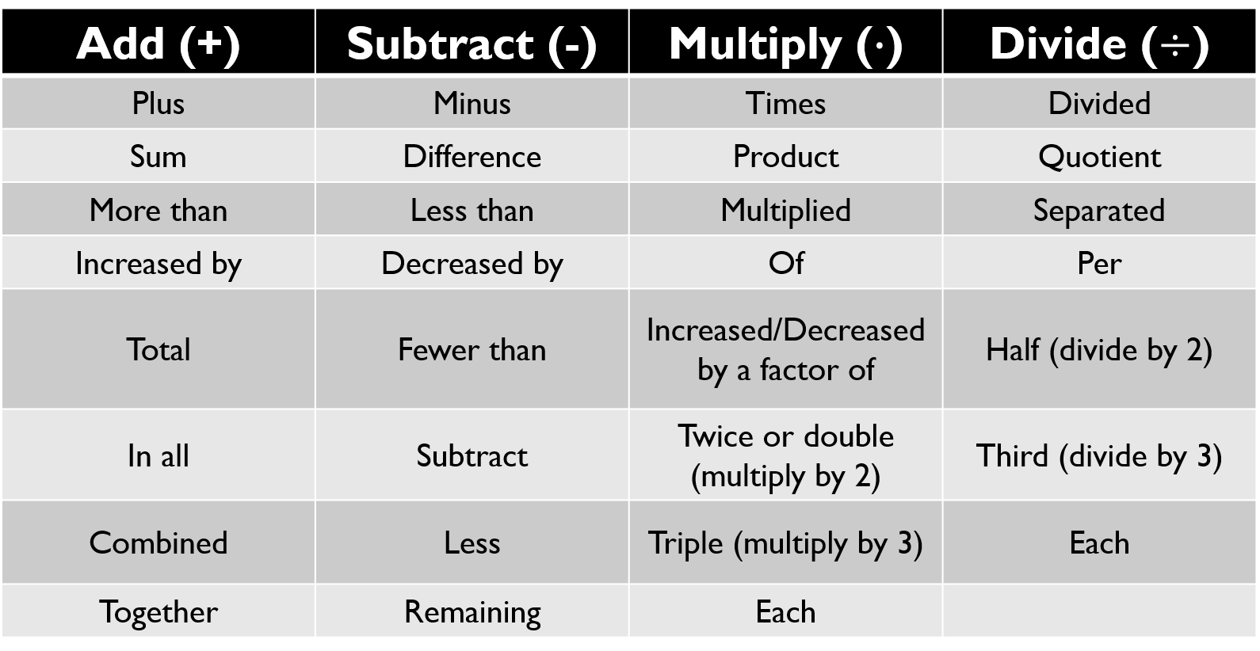
Key words—when breaking down word problems. It is good to know what words will be used to represent the operations because, usually, they will not simply say ‘add,’ ‘subtract,’ ‘multiply,’ or ‘divide.’

L
LCD—least common denominator
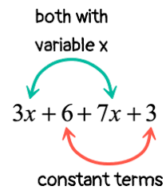
Likely event—an event with a 51-99% chance of taking place. It is very likely but still have a chance to not happen.
Like terms—terms that contain the same variables and constants raised to the same powers

Linear—an equation or function that forms a straight line
Nonlinear
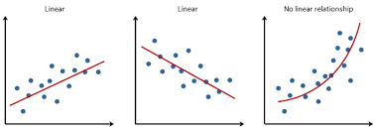
Linear
Linear

Lower quartile (for box and whisker plots)—the median of the lower values that are below the median of the entire data set

M
Markups—when a store buys an item, then adds a percentage to the total in order to sell it to you for a profit. You must do the markup and taxes from the marked-up price.
Maximum value (in box and whisker plots)—the largest piece/value of data in your data set (greatest)
Mean—the average, found by adding all your data together and dividing by how many separate pieces of data you have
Measures of center or measures of central tendency— are used when describing a set of data by identifying the central (center) position of the data (measures of center include mean, median, and mode)
Median—the middle number, found by putting the numbers in numerical order from least to greatest and identifying the number or numbers in the center of the data set.
Minimum value (in box and whisker plots)—the smallest piece/value of data in your data set (smallest)
Mixed number—a fraction that contains both a whole number and a proper fraction, for example: $2\frac{1}{2}$
Mode—the number or numbers that occur the most often in your data set
Multiplier—the number you can multiply by in order to increase or decrease an amount
Mutually exclusive events—two events that cannot occur at the same time. For example, rolling a 3 or a 5 on a die. They cannot occur at the same time with a single die, therefore they are mutually exclusive from each other.

N
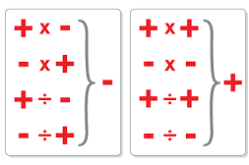
Natural numbers—the counting numbers {1, 2, 3, 4, 5….}

Negative and Positive $+(-)$or $(-)+$: any combination of a negative and a positive sign, when multiplied or divided, will result in a negative outcome

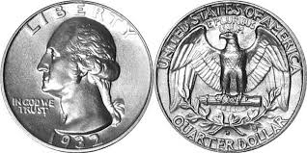
Neither likely nor unlikely event—has a 50% chance of taking place. Something that is equally likely to happen as it is to not happen (can also be classified as equally likely as unlikely). An example would be flipping a coin.

Non-linear—an equation or function that does not form a straight line
Non-proportional—a relationship that does not go through the origin, does not form a straight line, or does not have a unit rate
A non-proportional table example:

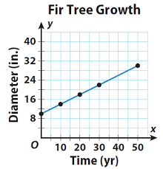
A non-proportional graph example:

Non-uniform probability—a probability experiment in which all events DO NOT have an equal chance of occurring. For example: when spinning a spinner that is $\frac{3}{4}$ blue and $\frac{1}{4}$ red, it is more likely to land on blue than to land on red, meaning it is non-uniform.
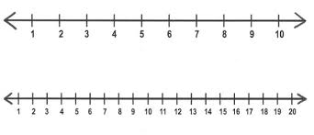
Number line—a line with equal distances marked off to represent numbers

Numerator—the top number of a fraction

Number System—a writing system for writing and categorizing numbers. The Venn Diagram below explains what numbers are included in what categories
Breakdown:
- Rational numbers include—integers, whole numbers, and natural numbers
- Integers include—whole numbers and natural numbers
- Whole numbers include—natural numbers
- Natural numbers do not include anything other than natural numbers
- Irrational numbers are categorized all on their own

O
Opposite quantities—a zero pair; when two numbers that combine equal to zero. For example, 2 and $-2$ are opposite quantities because they make zero
Ordered pair—is the composition of an x coordinate and a y coordinate having a fixed order within the parenthesis $(x,y)$ graphed by going either left of right on the x axis (determined if the point is positive or negative) and then from that location either up or down on the y axis (determined if the point is positive or negative
Order of operations—PEMDAS

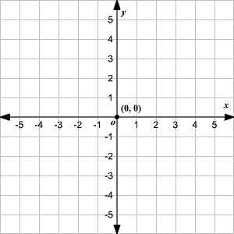

Origin: the point (0,0) on a coordinate plane. The very center of the coordinate plane where the x and y axis cross each other.

Or probability—the probability of Event A or Event B occurring is the sum of their individual probabilities$.$
$$P(A or B)=P(A)+P(B)$$

Outcome—any possible or actual result, such as rolling a 5 on a standard number cute or getting tails when flipping a coin.

Overlapping probability—If one or more of the events happen at the same time. For example, rolling an even number or a prime number one a die. (Even numbers include 2, 4, 6. And Prime numbers include 2, 3, 5. The number 2 would be counted twice, which is a form of overlap.)

Obtuse angle: an angle that measure greater than 90 degrees
P
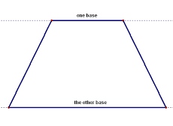
Parallel—two straight lines that will never intersect (when talking about parallel objects, they are side by side having the same distance continuously between them)
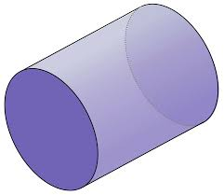

Example of Parallel Lines
Example of Parallel 3D bases (the circular bases are parallel)
Example of Parallel 2D bases

Percent of change—the ratio of the amount of change to the original amount (this can be an increase or a decrease)
percent of change formula (for increase AND decrease) = $\frac{amount of change}{original amount}$

Percent of decrease—describes how much the original amount of something has decreased
Percent of error—a ratio that compares the inaccuracy of an estimate, or amount of error, to the actual amount
percent of error formula = $\frac{amount of error}{actual amount}$

Percent of increase—describes how much the original amount of something has increased
Perimeter—the distance around a figure/shape

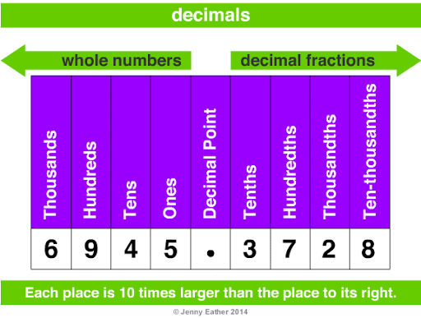
Place value—the position, or ‘place,’ of a digit in a number written in standard form that determines the actual blue the digit represents

Polygon— a plane figure with at least three straight sides and angles
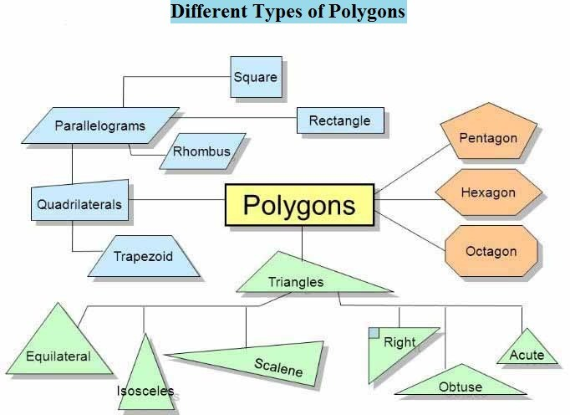
types of polygons are: triangles, square, rectangle, trapezoid, rhombus, parallelogram

Population sample—taking a subset of subjects to represent a population of individuals
Population—a group of subjects
Post-image
Post image—the secondary ‘new’ image that HAS had the scale factor applied to it
Pre-image
Pre-image: the original image that has NOT had the scale factor applied to it

Principal—the original sum of money (borrowed or invested)
Prism—a solid that has bases that are parallel, congruent polygons and sides that are parallelograms (they are names by the shape of their bases)

Probability—the likelihood that an even will or will not occur (can be written as a fraction, decimal, or a percentage)
Probability format—is $p(event)=answer$
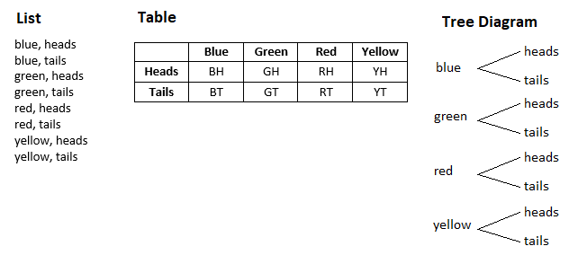
Probability models—a model of a real-life situation that involves probability. Creating and working with models can help to answer mathematical probability to real life and make predictions about actual events occurring in the world outside of the classroom. (You could see the following, a list, a table, or a tree diagram)

Profit—the money earned when a business sells products or services for more than the cost to produce them
Proper fraction—a fraction that is less than one with a numerator that is less than the denominator. For example: $\frac{3}{4}$

Properties of multiplication—

Proportion—a part or share of a whole
To solve for any proportion use the following formula: $\frac{part (is)}{whole (of)}=\frac{\% (part)}{100 (whole)}$

Proportional—a relationship with a constant ratio, that when graphed, passes through the origin and forms a straight line

Proportional relationship—as x increases, y increases at the same rate. Oppositely as x decreases, y decreases at the same rate
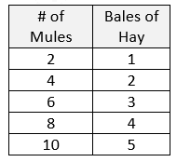
An example of a proportional table

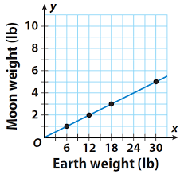
An example of a proportional graph

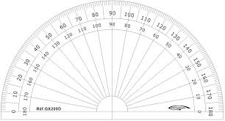

Protractor—an instrument used for measuring angles

Pyramid—a geometric shape with either a square, rectangular, or triangular base with a given number of faces that meet at an apex

Q
Quantities—the amount or number of something
Quadrilateral—a four-sided polygon. Examples of quadrilaterals are:
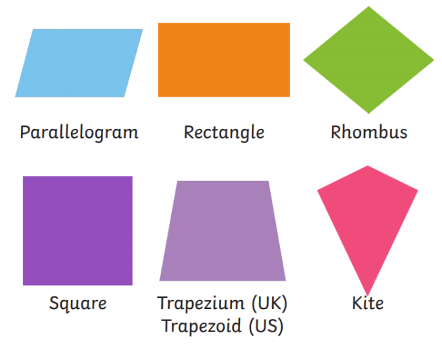

R
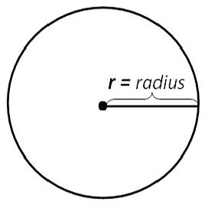
Radius—the distance from one side of the circle to the center point of a circle (the radius ONLY touches one side of the circle and the center at a time)

Random event—outcomes that occur at random if each outcome has an equally likely chance to occur
Random sample—the process of sampling a group of people where the selection is done by chance
Range—the distance from the highest number in a data set to the lower number in a data set
For example, the range of the following data set is 7: $(8-1=7 the distane from 1→8 is seven spaces)$
Data set: 1, 6, 5, 7, 8

Rate—compares two quantities and how one quantity is affected when another quantity changes.
Ratio—is a fraction
Rational numbers—all positive and negative numbers, and zero (which is NOT positive OR negative), that can be written as a fraction. Terminating and repeating decimals are rational, also 1 is NOT a rational number
Reciprocal—if the product of two numbers is one, they are said to be reciprocals (flip the fraction)
$the reciprocal of\frac{1}{2} is \frac{2}{1} because when you multiply them together you get one$
Rectangular prism—a geometric figure with six quadrilateral faces (a cube can ALSO be classified as a rectangular prism)

Reduction (in scale drawings): if the post-image is SMALLER than the pre-image, or the scale factor is LESS than 1, 100% or 1.0
Post-image
Pre-image

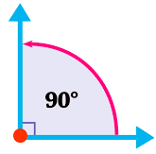
Repeating decimal—has a digit or group of digits after the decimal point that repeats without end. For example: 0.11111… OR $0.\overline{1}$ OR $\frac{1}{9}$
Replacement—when an item is replaced (put back) and then included in the next event
Right angle—an angle that measures exactly $90°$ (degrees). This will usually be indicated with a small scare in the edge of the angle.
Right angle
Right prism: a geometric solid that has a polygon as its base and sides perpendicular to the base. It is called ‘right’ because all the angles are right angles
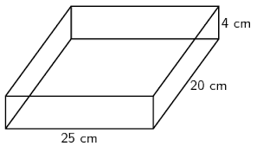
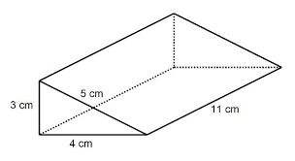
Right Rectangular Prism
Right Triangular Prism

Rule of inequalities—If both sides are multiplied or divided by a negative number you MUST flip your inequality sign to face the opposite direction
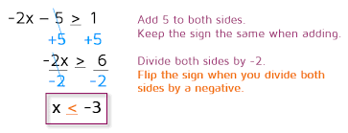

S
Sale price—the price of an item AFTER a discount has been applied
Scale Drawing Example--blueprint
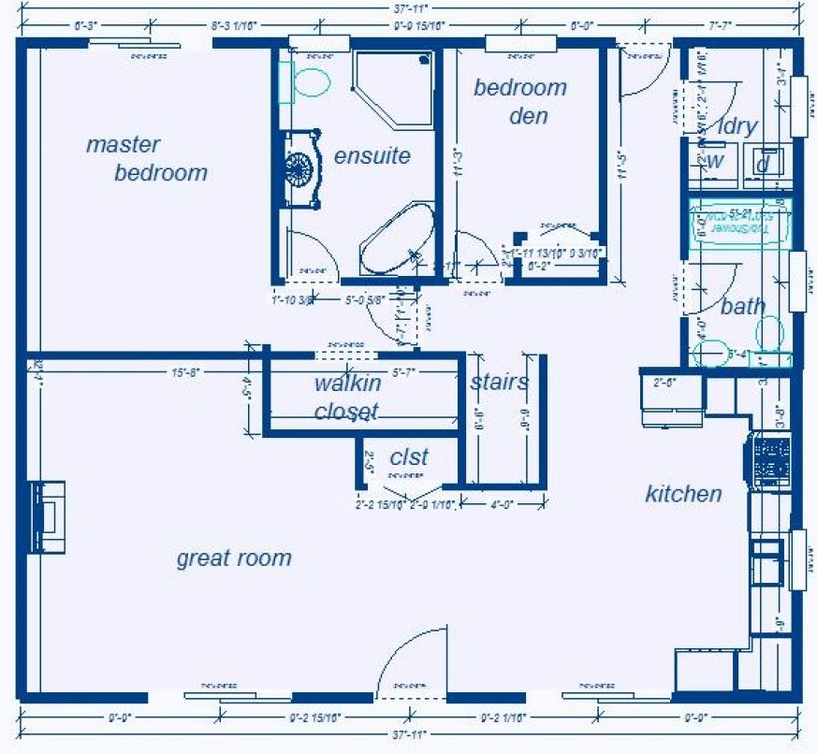
Sample space—all possible outcomes of a situation. For example, the sample space for flipping a coin is heads and tails because those are the only two outcomes possible; rolling a standard number cube has six possible outcomes: 1, 2, 3, 4, 5, and 6, because those are all the numbers on the die.
Scale drawing—Is an enlarged or reduced drawing of an actual object (has been enlarged or reduced by a specific scale)
Scale factor—a ratio that compares the sizes of parts of one figure or object to the sizes of the corresponding parts of the similar figure or object
Scale factor formula: $\frac{copy}{original}$

Scale factor—the ratio of two corresponding sides in a set of similar figures that help determine if an enlargement or reduction have taken place
Semi-circle—half of a circle
Semi-circle

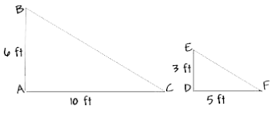
Similar figures—two images or figures that are the same shape but are NOT the same size. They will have equivalent ratios of the lengths of their corresponding sides and their angle measurements will be equivalent, but the physical SIZE will be different.

For example:

Simple interest—the money earned on the principal invested or borrowed
Sphere—a round, solid, three-dimensional geometric figure

Standard form for a circle area or circumference problem—this means that when you are working out a problem to find the area of circumference of a circle you multiply by pi

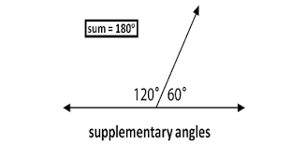
Subset—Is a smaller part of a much larger group of related things
Supplementary angles—angles whose sum is 180 degrees
Surface area—the total area of all the faces of a three-dimensional object or figure

T
Term—parts of an algebraic expression separated by either an addition or a subtraction sign
*Notice that this expression has FOUR terms.
*When you have parenthesis, you could the ENTIRETY of the parenthesis as ONE term
$$3x+4-{3x}^{2}+(2+5x)$$
term
term
term
term

Terminating decimal—a finite number of digits after the decimal point (a number that stops), and can always be written as a fraction (note, NOT all fraction are terminating decimals). For example, 0.2 is terminating because it stops in the tenths place
Theoretical probability—what is expected to happen based off an observation. For example, I have a $\frac{1}{6}$ chance of rolling a 5 on a die, simply because there are six numbers and only one of them is the number 5.
Theoretical probability = 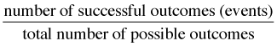
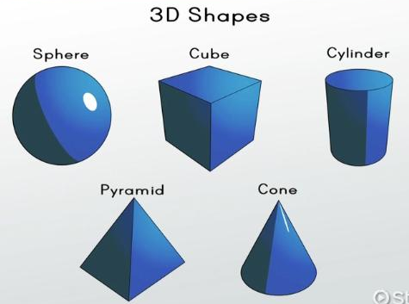
Three-dimensional figures (3D figures)—a solid figure with a length, width, and height
Time (with interest)—the number of years or partial years a loan is borrowed/interest time is gained
Triangle—a three-sided, two-dimensional polygon

Triangular Prism—a three-sided prism with a triangular base
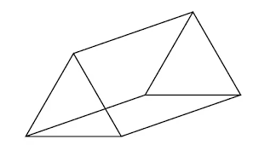
Triangular Prism

Triangular Pyramid—a geometric figure composed of four triangular faces
Triangular Pyramid

Two-dimensional figures (2D figures)—a shape with only a width and a height
2D Shapes
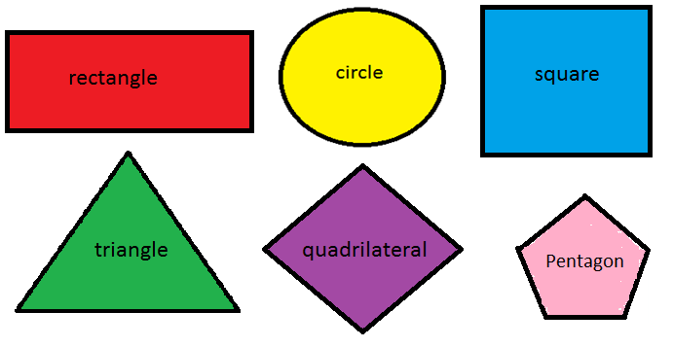

Two step equations—are equations where you have two numbers to remove to get the variable alone
Two step inequalities—are inequalities where you have two numbers to remove to get the variable alone
Two Step Equation Example
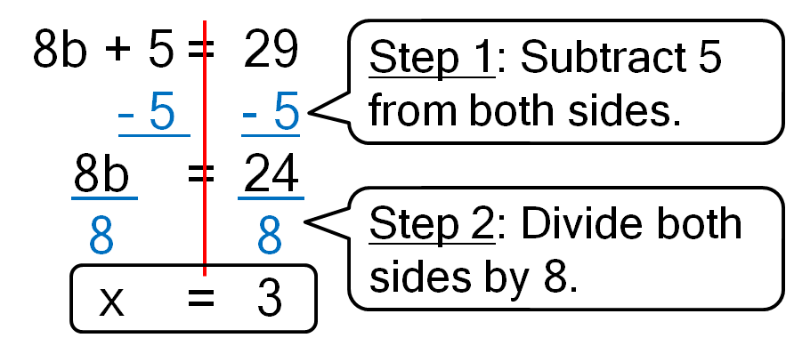

Two Step Inequality Example
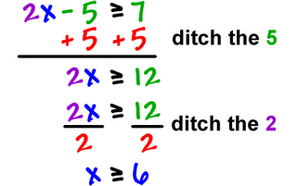
Step 1: Add 5 to both sides.
Step 1: Add 5 to both sides

Step 2: Divide both sides by 2.

U
Uniform Probability Model
Uniform probability—a probability experiment in which all events have an equal chance of occurring. For example, flipping a coin, the coin is equally likely to land on heads as it is to land on tails. When spinning a spinner with 4 equal sections, the spinner has an equal chance to land on all 4 colors.

Unit Rate—refers to one of something
Unit Rate Example
Other words commonly used for Unit Rate that you will see—Constant of Proportionality, Unit Rate, “K” (the variable is representational in the formula), COP (an abbreviation for constant of proportionality), Unit Price, Unit Cost, Constant Multiplier
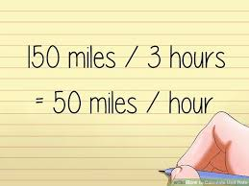

Unit Rate Formula—is $y=kx$ where $y$ is the dependent variable information, $k$ is the unit rate, and$x$ is the independent variable information
Other formats of the SAME equation you will see:
Solving for the Unit Rate: $k=y∙x$
Solving for the Independent (x): $x=\frac{y}{k}$

Unlikely event: an event with a 49%-1% chance of taking place. This event would be very unlikely to happen, but still has a small possibility.

Upper quartile (with box and whisker plots)—the median of data values above the median of the entire data set
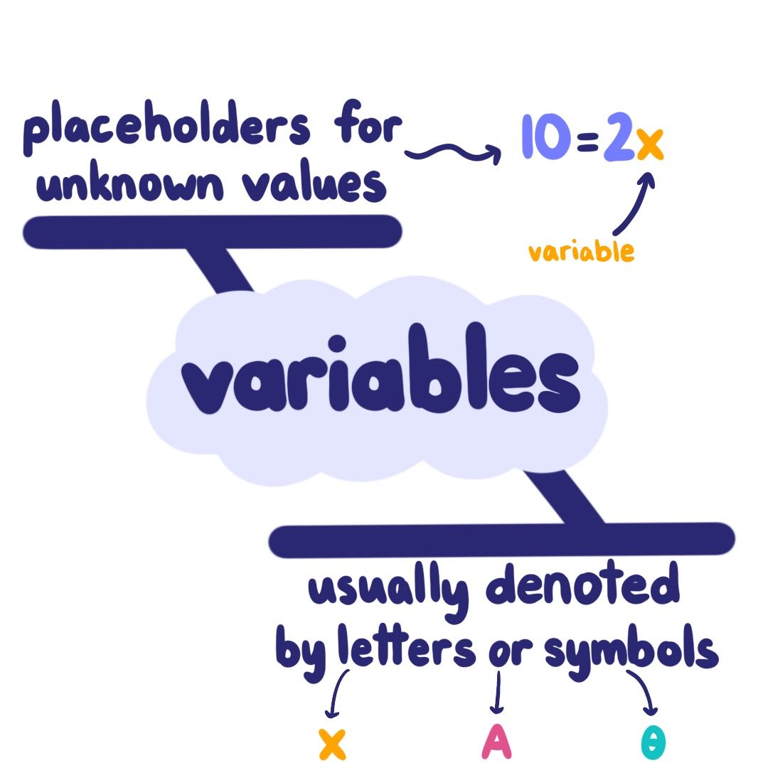
V
Variable—a symbol for a number that we don’t know the quantity/value of yet
Variation—a change or difference in a condition, amount, level, ect.
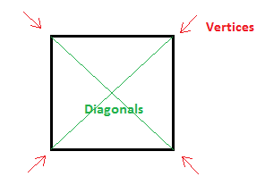
Vertex—(plural vertices) each angular point on a figure (both 3D and 2D)
2D figure
3D figure
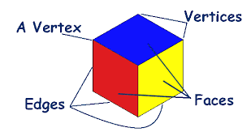

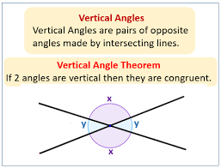
Vertical angles—a pair of non-adjacent angles that have equivalent angle measurements

Visual overlap—the degree of two numerical data distributions with similar variations, measuring the different between their centers

Volume—refers to the amount of physical space a 3D object takes up
Volume of a cone—is $\frac{1}{3}∙π∙{radius}^{2}∙height$
Volume of a cube—is $length∙width∙height$
Volume of a cylinder—is $π∙{radius}^{2}∙height$
Volume of a rectangular prism—is $length∙width∙height$
Volume of a rectangular pyramid—is $\frac{1}{3}∙base∙height$
Cone
Cylinder
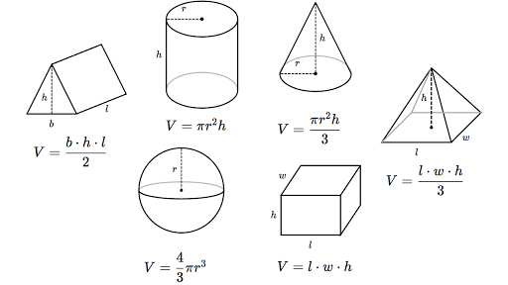
Volume of a sphere—is $\frac{4}{3}∙π∙{radius}^{3}$
Rectangular Pyramid
Triangular Prism
Volume of a triangular prism—is $\frac{base∙length∙height}{2}$

Rectangular Prism
Sphere

W
Whole number: a number that has no fractional or decimal parts and no negatives, this includes all the counting numbers and zero {0, 1, 2, 3….}

